//  Arrays are used to store multiple values in a single variable, instead of declaring separate variables for each value.

// To create an array, define the data type (like int) and specify the name of the array followed by square brackets [].

// To insert values to it, use a comma-separated list, inside curly braces:

data_type name [size]

ex:

int array [10]

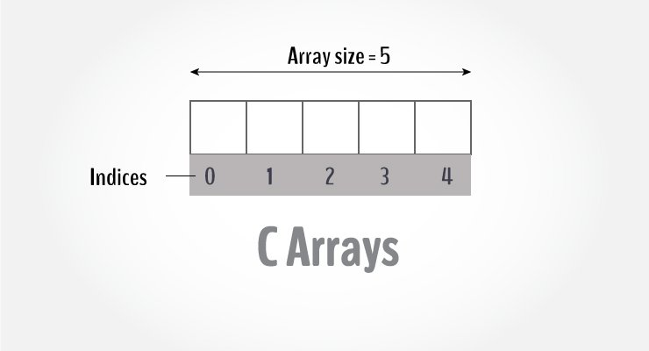

**Few keynotes**:

* Arrays have 0 as the first index, not 1. In this example, mark[0] is the first element.
* If the size of an array is n, to access the last element, the n-1 index is used. In this example, mark[4]
* Suppose the starting address of mark[0] is **2120d**. Then, the address of the mark[1] will be **2124d**. Similarly, the address of mark[2] will be **2128d** and so on.  
  This is because the size of a **float is 4 bytes.**

Initialization in C is the process to assign some initial value to the variable. When the array is declared or allocated memory, the elements of the array contain some garbage value. So, we need to initialize the array to some meaningful value. There are multiple ways in which we can initialize an array in C.